ISYE 6501, Week 6 HW

**Question 1**

Using the same crime data set as in Homework 5 Question 2, apply Principal Component Analysis and then create a regression model using the first 4 principal components. Specify your new model in terms of the original variables (not the principal components), and compare its quality to that of your solution to Homework 5 Question 2. You can use the R function prcomp for PCA. (Note that to first scale the data, you can include scale. = TRUE to scale as part of the PCA function.)

**Response –**

After PCA, the regression model came out to be –

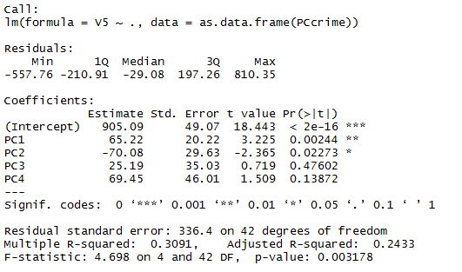

Regression equation –

Crime rate = 905.1 - 21.28M + 10.22So + 14.32*Ed + 63.45*Po1 + 64.55*Po2 -14.005*LF – 24.44*MF + 39.83*Pop + 15.43*NW -27.23*U1 + 1.42*U2 + 38.6*Wealth - 27.5*Ineq + 3.29*Prob – 6.612*Time